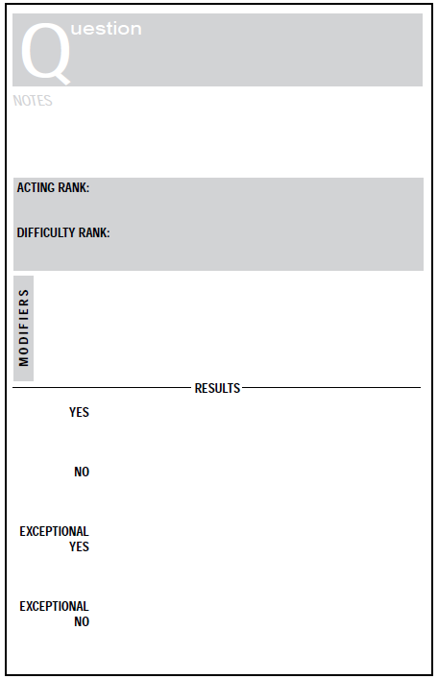

The player moves as normal.

The player cannot move this turn, and is immobilized by the terrain. Suffers -2RS in combat.

The player moves at half their normal speed (without modifiers). Suffers -1RS in combat.

The player moves as normal.

Strength / Reflex (average the two)

The rank of the difficult terrain

When a player is attempting to move through terrain that has been labeled as 'difficult', check to see if the player can move

Can I move through the difficult terrain?



The creature is detected.

The creature is not detected. And if it attacks it get a +1 RS to its attack for the surprise attack.

The creature is not detected.

The creature is detected.

* DR +1 RS, if creature is camouflaged or has cover.
* AR +1 RS, if creature has lower IQ/Intuition (average of two) of the player attempting the detection.

Intuition

When a player is trying to sense via the 5 senses any other NPC that is within range of his senses.

Can I perceive anything?

IQ/Intuition (average of two) of creature trying to be detected.







